**Improved Web Design Using CSS/Bootstrap**

**LAB: 04**



**Spring-22**

Submitted by: **Ashfaq Ahmad** Registration No: **19PWCSE1795** Class Section: **B**

“On my honor, as a student of the University of Engineering and Technology, I have neither given nor received unauthorized assistance on this academic work.”

Student Signature:

Submitted to: **Engr.Naina Said** May 1, 2022

Department of Computer Systems Engineering University of Engineering and Technology, Peshawar

## Objectives:

* To know about Dynamic HTML
* To know about CSS and Bootstrap
  1. Font attributes
  2. Color and background attributes
  3. Text attributes
  4. Border and margin attributes
* To know about Web hosting

# Task 4.1

Write the HTML code that generates the output web page shown in Figure 4.4 with following specification:

1. Heading 1 has font value of Arial and Helvetica, size 26 pts, and red color.
2. Each paragraph is 12 pts, bold, and italic. Take paragraph color value: #23238e
3. Use groove border style and thick border width. For reference, go to Table 4.4 for further details about border attributes.

**Source Code:**

<!DOCTYPE html>

<html>

<head>

<title>Working with Style Sheet</title>

<style type="text/css"> h1 {

*font-family*: Arial, Helvetica;

*font-size*: 26pt;

*color*: red;

}

p {

*font-size*: 12pt; *font-weight*: bold; *font-style*: italic; *color*: #23238e; *border-style*: groove; *border-width*: thick;

}

</style>

<body>

<h1>Silicon Chip Technologies</h1>

<p>A private limited company, which was founded in December 1989. The vision of this company is to provide any

corporate client a single entity which addresses all their software Development, Technical and User

Documentation,Training and Manpower Recruitment needs.</p>

</body>

</head>

</html>

**Output:**

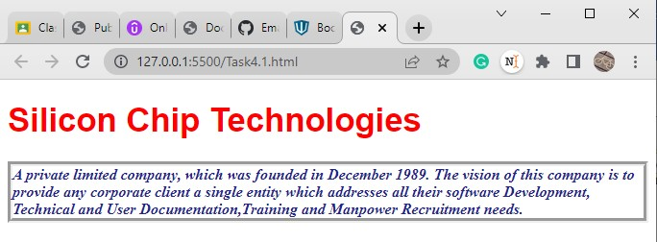

# Task 4.2

Write the HTML code that generates the output web page shown in Figure 4.6 with following specification:

1. Heading 1 has font value of Garamond, size 26 pts, and red color.
2. Set top margin to 5%.
3. Create unordered list with values: HTML, JavaScript, CGI, Java, Oracle Developer 2000, and Oracle DBA. Use square list style type.

**Sourc**

<!DOCTYPE html>

<html>

<head>

<title>Working with Style Sheet</title>

<style type="text/css"> h1 {

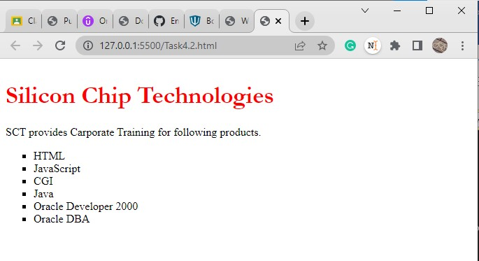**Output:**

# Task 4.3

Write the **HTML code along with CSS file** that generates the output web page shown in Figure 4.6.

**Source Code: HTML Code:**

<!DOCTYPE html>

<html>

<head>

<title>Working with Style Sheet</title>

<link rel="stylesheet" href="Task4.3.css">

</head>

<body>

<h1>Silicon Chip Technologies</h1>

<p>SCT provides Carporate Training for following products.</p>

<ul>

<li>HTML</li>

<li>JavaScript</li>

<li>CGI</li>

<li>Java</li>

<li>Oracle Developer 2000</li>

<li>Oracle DBA</li>

</ul>

</body>

</html>

**CSS Code:**

h1 {

*font-family*: garamond; *font-size*: 26pt; *color*: red;

*margin-top*: 5%;

}

ul {

*list-style*: square;

}

**Output:**

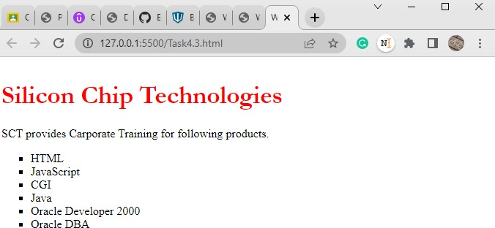

# Task 4.4

Rewrite Example 5 using ID Selector instead of class Selector and show its output.

**Source Code:**

<!DOCTYPE html>

<html>

<head>

<title> Use of Margin Attributes </title>

<style type="text/css"> p {

*font-size*: 12pt; *font-weight*: bold; *text-align*: justify; *margin-left*: 10%;

*margin-right*: 10%;

}

#question {

*color*: brown;

*font-style*: italic;

}

#answer {

*color*: #23238e

}

</style>

</head>

<body>

<p id="question">How to create style sheet to alter an HTML element?</p>

<p id="answer">The Style assignment process can be accomplished with the &lt;STYLE&gt;...&lt;/STYLE&gt; tags. The syntax for making the

assignment is simple. Between &lt;STYLE&gt; and &lt;/STYLE&gt;, HTML

tags pair of This

to which styles are to be assigned are to be listed ad each tag with a curly brackets in which specific style attributes are to be specified.

&lt;STYLE&gt; tag should be within &lt;HEAD&gt;...&lt;/HEAD&gt; element.</p>

<br>

<p id="question">What are the attributes that can be specified?</p>

<p id="answer">The attributes that can be specified are: Font attributes,

</body>

</html>

attributes, and List attributes.</p>

Margin

Color and Background attributes, Text attributes, Border attributes,

**Output:**

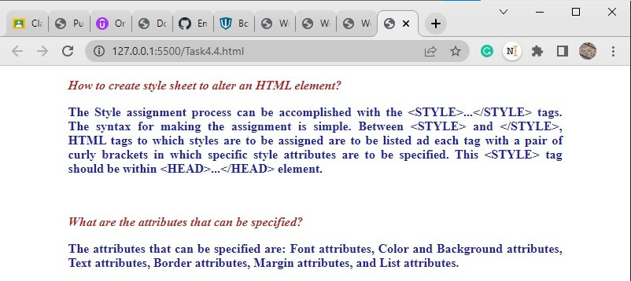

# Task 4.5

**Bootstrap:**

1. Download latest Bootstrap version (https://github.com/twbs/bootstrap/archive/v4.0.0.zip). Extract it. CSS files are located in folder bootstrap-4.0.0\dist\css and JS files are located in folder bootstrap-4.0.0\dist\js. Examples are located in folder bootstrap-4.0.0\docs\4.0\examples. Go through following examples: sign-in, cover, checkout, and blog. Modify these examples. Submit

the modified web pages and respective HTML and CSS files with description.

1. Complete the following tutorial, upload the files on web host, and provide the link: https://websitesetup.org/bootstrap-tutorial-for-beginners/.

# Task 4.6

Design your CV using HTML, CSS, and Bootstrap and upload it on the hosting site. Provide the link.

**Source Code for Sign-in:**

<!doctype html>

<html lang="en">

<head>

<meta charset="utf-8">

<meta name="viewport" content="width=device-width, initial-scale=1, shrink- to-fit=no">

<meta name="description" content="">

<meta name="author" content="">

<link rel="icon" href="../../../../favicon.ico">

<title>Signin Template for Bootstrap</title>

<!-- Bootstrap core CSS -->

<link href="../../../../dist/css/bootstrap.min.css" rel="stylesheet">

<!-- Custom styles for this template -->

<link href="signin.css" rel="stylesheet">

</head>

<body class="text-center">

<form class="form-signin">

<img class="mb-4" src="https://getbootstrap.com/assets/brand/bootstrap- solid.svg" alt="" width="72" height="72">

<h1 class="h3 mb-3 font-weight-normal">Please sign in</h1>

<label for="inputEmail" class="sr-only">Email address</label>

<input type="email" id="inputEmail" class="form-control" placeholder="Email address" required autofocus>

<label for="inputPassword" class="sr-only">Password</label>

<input type="password" id="inputPassword" class="form-control" placeholder="Password" required>

<label for="text" class="sr-only">Name:Ashfaq Ahmad</label>

<input type="text" id="text" class="form-control" placeholder="Name:Amir Suliman" required>

<label for="text" pattern="[a-zA-Z'-'\s]*" class="sr-only">RegNO:</label>

<input type="text" id="text" class="form-control" placeholder="RegNO" required>

<div class="checkbox mb-3">

<label>

<input type="checkbox" value="remember-me"> Remember me

</label>

</div>

<button class="btn btn-lg btn-primary btn-block" type="submit">Sign in</button>

<p class="mt-5 mb-3 text-muted">&copy; April 20, 2022-May 1, 2022</p>

</form>

</body>

</html>

html, body {

*height*: 100%;

}

body {

*display*: -ms-flexbox; *display*: -webkit-box; *display*: flex;

*-ms-flex-align*: center;

*-ms-flex-pack*: center;

*-webkit-box-align*: center;

*align-items*: center;

*-webkit-box-pack*: center; *justify-content*: center; *padding-top*: 40px; *padding-bottom*: 40px;

*background-color*: #f5f5f5;

}

.form-signin {

*width*: 100%;

*max-width*: 330px; *padding*: 15px; *margin*: 0 auto;

}

.form-signin .checkbox {

*font-weight*: 400;

}

.form-signin .form-control {

*position*: relative;

*box-sizing*: border-box;

*height*: auto; *padding*: 10px; *font-size*: 16px;

}

.form-signin .form-control:focus {

*z-index*: 2;

}

.form-signin input[type="email"] {

*margin-bottom*: -1px;

*border-bottom-right-radius*: 0;

*border-bottom-left-radius*: 0;

}

.form-signin input[type="password"] {

*margin-bottom*: 10px;

*border-top-left-radius*: 0;

*border-top-right-radius*: 0;

}

## Output:

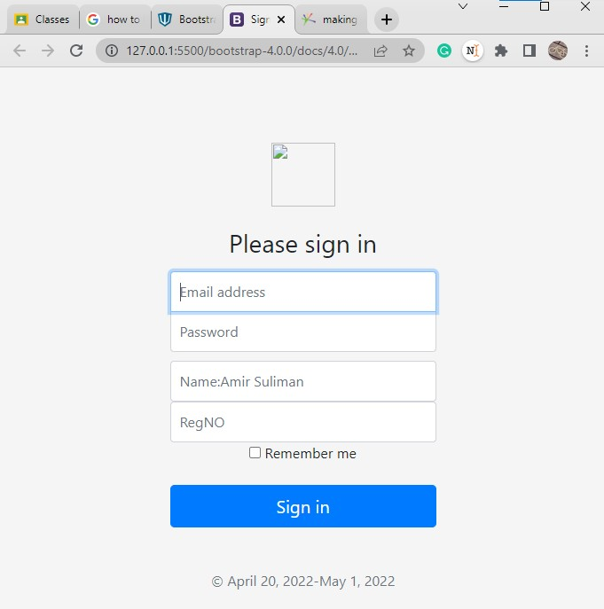

**Source Code for CheckOut:**

<!doctype html>

<html lang="en">

<head>

<meta charset="utf-8">

<meta name="viewport" content="width=device-width, initial-scale=1, shrink- to-fit=no">

<meta name="description" content="">

<meta name="author" content="">

<link rel="icon" href="../../../../favicon.ico">

<title>Checkout example for Bootstrap</title>

<!-- Bootstrap core CSS -->

<link href="../../../../dist/css/bootstrap.min.css" rel="stylesheet">

<!-- Custom styles for this template -->

<link href="form-validation.css" rel="stylesheet">

</head>

<body class="bg-light">

<div class="container">

<div class="py-5 text-center">

<img class="d-block mx-auto mb-4" src="https://getbootstrap.com/assets/brand/bootstrap-solid.svg" alt=""

width="72" height="72">

<h2>Checkout form</h2>

<p class="lead">Below is an example form built entirely with Bootstrap's form controls. Each required form group

has a validation state that can be triggered by attempting to submit the form without completing it.</p>

</div>

<div class="row">

<div class="col-md-4 order-md-2 mb-4">

<h4 class="d-flex justify-content-between align-items-center mb-3">

<span class="text-muted">Your cart</span>

<span class="badge badge-secondary badge-pill">3</span>

</h4>

<ul class="list-group mb-3">

<li class="list-group-item d-flex justify-content-between lh- condensed">

<div>

<h6 class="my-0">Product name</h6>

<small class="text-muted">Brief description</small>

</div>

<span class="text-muted">$12</span>

</li>

<li class="list-group-item d-flex justify-content-between lh- condensed">

<div>

<h6 class="my-0">Second product</h6>

<small class="text-muted">Brief description</small>

</div>

<span class="text-muted">$8</span>

</li>

<li class="list-group-item d-flex justify-content-between lh- condensed">

<div>

<h6 class="my-0">Third item</h6>

<small class="text-muted">Brief description</small>

</div>

<span class="text-muted">$5</span>

</li>

<li class="list-group-item d-flex justify-content-between bg-light">

<div class="text-success">

<h6 class="my-0">Promo code</h6>

<small>EXAMPLECODE</small>

</div>

<span class="text-success">-$5</span>

</li>

<li class="list-group-item d-flex justify-content-between">

<span>Total (USD)</span>

<strong>$20</strong>

</li>

</ul>

<form class="card p-2">

<div class="input-group">

<input type="text" class="form-control" placeholder="Promo code">

<div class="input-group-append">

<button type="submit" class="btn btn-secondary">Redeem</button>

</div>

</div>

</form>

</div>

<div class="col-md-8 order-md-1">

<h4 class="mb-3">Billing address</h4>

<form class="needs-validation" novalidate>

<div class="row">

<div class="col-md-6 mb-3">

<label for="firstName">First name</label>

<input type="text" class="form-control" id="firstName" placeholder="" value="" required>

<div class="invalid-feedback"> Valid first name is required.

</div>

</div>

<div class="col-md-6 mb-3">

<label for="lastName">Last name</label>

<input type="text" class="form-control" id="lastName" placeholder="" value="" required>

<div class="invalid-feedback"> Valid last name is required.

</div>

</div>

</div>

<div class="mb-3">

<label for="username">Username</label>

<div class="input-group">

<div class="input-group-prepend">

<span class="input-group-text">@</span>

</div>

<input type="text" class="form-control" id="username" placeholder="Username" required>

<div class="invalid-feedback" style="width: 100%;"> Your username is required.

</div>

</div>

</div>

<div class="mb-3">

<label for="email">Email <span class="text- muted">(Optional)</span></label>

<input type="email" class="form-control" id="email" placeholder="[you@example.com](mailto:you@example.com)">

<div class="invalid-feedback">

Please enter a valid email address for shipping updates.

</div>

</div>

<div class="mb-3">

<label for="address">Address</label>

<input type="text" class="form-control" id="address" placeholder="1234 Main St" required>

<div class="invalid-feedback"> Please enter your shipping address.

</div>

</div>

<div class="mb-3">

<label for="address2">Address 2 <span class="text- muted">(Optional)</span></label>

<input type="text" class="form-control" id="address2" placeholder="Apartment or suite">

</div>

required>

required>

address">

<div class="row">

<div class="col-md-5 mb-3">

<label for="country">Country</label>

<select class="custom-select d-block w-100" id="country"

<option value="">Choose...</option>

<option>United States</option>

</select>

<div class="invalid-feedback"> Please select a valid country.

</div>

</div>

<div class="col-md-4 mb-3">

<label for="state">State</label>

<select class="custom-select d-block w-100" id="state" required>

<option value="">Choose...</option>

<option>California</option>

</select>

<div class="invalid-feedback"> Please provide a valid state.

</div>

</div>

<div class="col-md-3 mb-3">

<label for="zip">Zip</label>

<input type="text" class="form-control" id="zip" placeholder=""

<div class="invalid-feedback"> Zip code required.

</div>

</div>

</div>

<hr class="mb-4">

<div class="custom-control custom-checkbox">

<input type="checkbox" class="custom-control-input" id="same-

<label class="custom-control-label" for="same-address">Shipping

address is the same as my billing

address</label>

</div>

<div class="custom-control custom-checkbox">

<input type="checkbox" class="custom-control-input" id="save-info">

<label class="custom-control-label" for="save-info">Save this information for next time</label>

</div>

<hr class="mb-4">

<h4 class="mb-3">Payment</h4>

<div class="d-block my-3">

<div class="custom-control custom-radio">

<input id="credit" name="paymentMethod" type="radio" class="custom-control-input" checked required>

<label class="custom-control-label" for="credit">Credit

card</label>

</div>

<div class="custom-control custom-radio">

<input id="debit" name="paymentMethod" type="radio" class="custom-control-input" required>

<label class="custom-control-label" for="debit">Debit

card</label>

</div>

<div class="custom-control custom-radio">

<input id="paypal" name="paymentMethod" type="radio" class="custom-control-input" required>

<label class="custom-control-label" for="paypal">Paypal</label>

</div>

</div>

<div class="row">

<div class="col-md-6 mb-3">

<label for="cc-name">Name on card</label>

<input type="text" class="form-control" id="cc-name" placeholder="" required>

<small class="text-muted">Full name as displayed on card</small>

<div class="invalid-feedback"> Name on card is required

</div>

</div>

<div class="col-md-6 mb-3">

<label for="cc-number">Credit card number</label>

<input type="text" class="form-control" id="cc-number" placeholder="" required>

<div class="invalid-feedback"> Credit card number is required

</div>

</div>

</div>

<div class="row">

<div class="col-md-3 mb-3">

<label for="cc-expiration">Expiration</label>

<input type="text" class="form-control" id="cc-expiration" placeholder="" required>

<div class="invalid-feedback"> Expiration date required

</div>

</div>

<div class="col-md-3 mb-3">

<label for="cc-expiration">CVV</label>

<input type="text" class="form-control" id="cc-cvv" placeholder="" required>

<div class="invalid-feedback"> Security code required

</div>

</div>

</div>

<hr class="mb-4">

<button class="btn btn-primary btn-lg btn-block" type="submit">Continue to checkout</button>

</form>

</div>

</div>

<footer class="my-5 pt-5 text-muted text-center text-small">

<p class="mb-1">&copy; 2017-2018 Company Name</p>

<ul class="list-inline">

<li class="list-inline-item"><a href="#">Privacy</a></li>

<li class="list-inline-item"><a href="#">Terms</a></li>

<li class="list-inline-item"><a href="#">Support</a></li>

</ul>

</footer>

</div>

<!-- Bootstrap core JavaScript

================================================== -->

<!-- Placed at the end of the document so the pages load faster -->

<script src="https://code.jquery.com/jquery-3.2.1.slim.min.js" integrity="sha384-

KJ3o2DKtIkvYIK3UENzmM7KCkRr/rE9/Qpg6aAZGJwFDMVNA/GpGFF93hXpG5KkN" crossorigin="anonymous"></script>

<script>window.jQuery || document.write('<script src="../../../../assets/js/vendor/jquery-slim.min.js"><\/script>')</script>

<script src="../../../../assets/js/vendor/popper.min.js"></script>

<script src="../../../../dist/js/bootstrap.min.js"></script>

<script src="../../../../assets/js/vendor/holder.min.js"></script>

<script>

// Example starter JavaScript for disabling form submissions if there are invalid fields

(*function* () { 'use strict';

window.addEventListener('load', *function* () {

// Fetch all the forms we want to apply custom Bootstrap validation

styles to

*var* forms = document.getElementsByClassName('needs-validation');

// Loop over them and prevent submission

*var* validation = *Array*.prototype.filter.call(forms, *function* (*form*) {

*form*.addEventListener('submit', *function* (*event*) { if (*form*.checkValidity() === false) {

*event*.preventDefault(); *event*.stopPropagation();

}

*form*.classList.add('was-validated');

}, false);

});

}, false);

})();

</script>

</body>

</html>

.container {

*max-width*: 960px;

}

.border-top {

*border-top*: 1px solid #e5e5e5;

}

.border-bottom {

*border-bottom*: 1px solid #e5e5e5;

}

.border-top-gray {

*border-top-color*: #adb5bd;

}

.box-shadow {

*box-shadow*: 0 .25rem .75rem rgba(0, 0, 0, .05);

}

.lh-condensed {

*line-height*: 1.25;

}

**Source Code Blog:**

<!doctype html>

<html lang="en">

<head>

<meta charset="utf-8">

<meta name="viewport" content="width=device-width, initial-scale=1, shrink- to-fit=no">

<meta name="description" content="">

<meta name="author" content="">

<link rel="icon" href="../../../../favicon.ico">

<title>Blog Template for Bootstrap</title>

<!-- Bootstrap core CSS -->

<link href="../../../../dist/css/bootstrap.min.css" rel="stylesheet">

<!-- Custom styles for this template -->

<link href="https://fonts.googleapis.com/css?family=Playfair+Display:700,900" rel="stylesheet">

<link href="blog.css" rel="stylesheet">

</head>

<body>

<div class="container">

<header class="blog-header py-3">

<div class="row flex-nowrap justify-content-between align-items-center">

<div class="col-4 pt-1">

<a class="text-muted" href="#">Subscribe</a>

</div>

<div class="col-4 text-center">

<a class="blog-header-logo text-dark" href="#">Large</a>

</div>

<div class="col-4 d-flex justify-content-end align-items-center">

<a class="text-muted" href="#">

<svg xmlns=["http://www.w3.org/2000/svg"](http://www.w3.org/2000/svg) width="20" height="20" viewBox="0 0 24 24" fill="none"

stroke="currentColor" stroke-width="2" stroke-linecap="round" stroke-linejoin="round" class="mx-3">

<circle cx="10.5" cy="10.5" r="7.5"></circle>

<line x1="21" y1="21" x2="15.8" y2="15.8"></line>

</svg>

</a>

<a class="btn btn-sm btn-outline-secondary" href="#">Sign up</a>

</div>

</div>

</header>

<div class="nav-scroller py-1 mb-2">

<nav class="nav d-flex justify-content-between">

<a class="p-2 text-muted" href="#">World</a>

<a class="p-2 text-muted" href="#">U.S.</a>

<a class="p-2 text-muted" href="#">Technology</a>

<a class="p-2 text-muted" href="#">Design</a>

<a class="p-2 text-muted" href="#">Culture</a>

<a class="p-2 text-muted" href="#">Business</a>

<a class="p-2 text-muted" href="#">Politics</a>

<a class="p-2 text-muted" href="#">Opinion</a>

<a class="p-2 text-muted" href="#">Science</a>

<a class="p-2 text-muted" href="#">Health</a>

<a class="p-2 text-muted" href="#">Style</a>

<a class="p-2 text-muted" href="#">Travel</a>

</nav>

</div>

<div class="jumbotron p-3 p-md-5 text-white rounded bg-dark">

<div class="col-md-6 px-0">

<h1 class="display-4 font-italic">Title of a longer featured blog post</h1>

<p class="lead my-3">Multiple lines of text that form the lede, informing new readers quickly and efficiently

about what's most interesting in this post's contents.</p>

<p class="lead mb-0"><a href="#" class="text-white font-weight- bold">Continue reading...</a></p>

</div>

</div>

<div class="row mb-2">

<div class="col-md-6">

<div class="card flex-md-row mb-4 box-shadow h-md-250">

<div class="card-body d-flex flex-column align-items-start">

<strong class="d-inline-block mb-2 text-primary">World</strong>

<h3 class="mb-0">

<a class="text-dark" href="#">Featured post</a>

</h3>

<div class="mb-1 text-muted">Nov 12</div>

<p class="card-text mb-auto">This is a wider card with supporting text below as a natural lead-in to

additional content.</p>

<a href="#">Continue reading</a>

</div>

<img class="card-img-right flex-auto d-none d-md-block" data- src="holder.js/200x250?theme=thumb"

alt="Card image cap">

</div>

</div>

<div class="col-md-6">

<div class="card flex-md-row mb-4 box-shadow h-md-250">

<div class="card-body d-flex flex-column align-items-start">

<strong class="d-inline-block mb-2 text-success">Design</strong>

<h3 class="mb-0">

<a class="text-dark" href="#">Post title</a>

</h3>

<div class="mb-1 text-muted">Nov 11</div>

<p class="card-text mb-auto">This is a wider card with supporting text below as a natural lead-in to

additional content.</p>

<a href="#">Continue reading</a>

</div>

<img class="card-img-right flex-auto d-none d-md-block" data- src="holder.js/200x250?theme=thumb"

alt="Card image cap">

</div>

</div>

</div>

</div>

<main role="main" class="container">

<div class="row">

<div class="col-md-8 blog-main">

<h3 class="pb-3 mb-4 font-italic border-bottom"> From the Firehose

</h3>

<div class="blog-post">

<h2 class="blog-post-title">Sample blog post</h2>

<p class="blog-post-meta">January 1, 2014 by <a href="#">Mark</a></p>

<p>This blog post shows a few different types of content that's supported and styled with Bootstrap. Basic

typography, images, and code are all supported.</p>

<hr>

<p>Cum sociis natoque penatibus et magnis <a href="#">dis parturient montes</a>, nascetur ridiculus mus.

Aenean eu leo quam. Pellentesque ornare sem lacinia quam venenatis vestibulum. Sed posuere consectetur est

at lobortis. Cras mattis consectetur purus sit amet fermentum.</p>

<blockquote>

<p>Curabitur blandit tempus porttitor. <strong>Nullam quis risus eget urna mollis</strong> ornare vel eu

leo. Nullam id dolor id nibh ultricies vehicula ut id elit.</p>

</blockquote>

<p>Etiam porta <em>sem malesuada magna</em> mollis euismod. Cras mattis consectetur purus sit amet fermentum.

Aenean lacinia bibendum nulla sed consectetur.</p>

<h2>Heading</h2>

<p>Vivamus sagittis lacus vel augue laoreet rutrum faucibus dolor auctor. Duis mollis, est non commodo luctus,

nisi erat porttitor ligula, eget lacinia odio sem nec elit. Morbi leo risus, porta ac consectetur ac,

vestibulum at eros.</p>

<h3>Sub-heading</h3>

<p>Cum sociis natoque penatibus et magnis dis parturient montes, nascetur ridiculus mus.</p>

<pre><code>Example code block</code></pre>

<p>Aenean lacinia bibendum nulla sed consectetur. Etiam porta sem malesuada magna mollis euismod. Fusce

dapibus, tellus ac cursus commodo, tortor mauris condimentum nibh, ut fermentum massa.</p>

<h3>Sub-heading</h3>

<p>Cum sociis natoque penatibus et magnis dis parturient montes, nascetur ridiculus mus. Aenean lacinia

bibendum nulla sed consectetur. Etiam porta sem malesuada magna mollis euismod. Fusce dapibus, tellus ac

cursus commodo, tortor mauris condimentum nibh, ut fermentum massa justo sit amet risus.</p>

<ul>

et.</li>

<li>Praesent commodo cursus magna, vel scelerisque nisl consectetur

<li>Donec id elit non mi porta gravida at eget metus.</li>

<li>Nulla vitae elit libero, a pharetra augue.</li>

</ul>

<p>Donec ullamcorper nulla non metus auctor fringilla. Nulla vitae

elit libero, a pharetra augue.</p>

<ol>

<li>Vestibulum id ligula porta felis euismod semper.</li>

<li>Cum sociis natoque penatibus et magnis dis parturient montes, nascetur ridiculus mus.</li>

<li>Maecenas sed diam eget risus varius blandit sit amet non

magna.</li>

</ol>

<p>Cras mattis consectetur purus sit amet fermentum. Sed posuere consectetur est at lobortis.</p>

</div><!-- /.blog-post -->

<div class="blog-post">

<h2 class="blog-post-title">Another blog post</h2>

<p class="blog-post-meta">December 23, 2013 by <a href="#">Jacob</a></p>

<p>Cum sociis natoque penatibus et magnis <a href="#">dis parturient montes</a>, nascetur ridiculus mus.

Aenean eu leo quam. Pellentesque ornare sem lacinia quam venenatis vestibulum. Sed posuere consectetur est

at lobortis. Cras mattis consectetur purus sit amet fermentum.</p>

<blockquote>

<p>Curabitur blandit tempus porttitor. <strong>Nullam quis risus eget urna mollis</strong> ornare vel eu

leo. Nullam id dolor id nibh ultricies vehicula ut id elit.</p>

</blockquote>

<p>Etiam porta <em>sem malesuada magna</em> mollis euismod. Cras mattis consectetur purus sit amet fermentum.

Aenean lacinia bibendum nulla sed consectetur.</p>

<p>Vivamus sagittis lacus vel augue laoreet rutrum faucibus dolor auctor. Duis mollis, est non commodo luctus,

nisi erat porttitor ligula, eget lacinia odio sem nec elit. Morbi leo risus, porta ac consectetur ac,

vestibulum at eros.</p>

</div><!-- /.blog-post -->

<div class="blog-post">

<h2 class="blog-post-title">New feature</h2>

<p class="blog-post-meta">December 14, 2013 by <a href="#">Chris</a></p>

<p>Cum sociis natoque penatibus et magnis dis parturient montes, nascetur ridiculus mus. Aenean lacinia

bibendum nulla sed consectetur. Etiam porta sem malesuada magna mollis euismod. Fusce dapibus, tellus ac

cursus commodo, tortor mauris condimentum nibh, ut fermentum massa justo sit amet risus.</p>

<ul>

<li>Praesent commodo cursus magna, vel scelerisque nisl consectetur

et.</li>

<li>Donec id elit non mi porta gravida at eget metus.</li>

<li>Nulla vitae elit libero, a pharetra augue.</li>

</ul>

<p>Etiam porta <em>sem malesuada magna</em> mollis euismod. Cras

mattis consectetur purus sit amet fermentum.

Aenean lacinia bibendum nulla sed consectetur.</p>

<p>Donec ullamcorper nulla non metus auctor fringilla. Nulla vitae elit libero, a pharetra augue.</p>

</div><!-- /.blog-post -->

<nav class="blog-pagination">

<a class="btn btn-outline-primary" href="#">Older</a>

<a class="btn btn-outline-secondary disabled" href="#">Newer</a>

</nav>

</div><!-- /.blog-main -->

<aside class="col-md-4 blog-sidebar">

<div class="p-3 mb-3 bg-light rounded">

<h4 class="font-italic">About</h4>

<p class="mb-0">Etiam porta <em>sem malesuada magna</em> mollis euismod. Cras mattis consectetur purus sit

amet fermentum. Aenean lacinia bibendum nulla sed consectetur.</p>

</div>

<div class="p-3">

<h4 class="font-italic">Archives</h4>

<ol class="list-unstyled mb-0">

<li><a href="#">March 2014</a></li>

<li><a href="#">February 2014</a></li>

<li><a href="#">January 2014</a></li>

<li><a href="#">December 2013</a></li>

<li><a href="#">November 2013</a></li>

<li><a href="#">October 2013</a></li>

<li><a href="#">September 2013</a></li>

<li><a href="#">August 2013</a></li>

<li><a href="#">July 2013</a></li>

<li><a href="#">June 2013</a></li>

<li><a href="#">May 2013</a></li>

<li><a href="#">April 2013</a></li>

</ol>

</div>

<div class="p-3">

<h4 class="font-italic">Elsewhere</h4>

<ol class="list-unstyled">

<li><a href="#">GitHub</a></li>

<li><a href="#">Twitter</a></li>

<li><a href="#">Facebook</a></li>

</ol>

</div>

</aside><!-- /.blog-sidebar -->

</div><!-- /.row -->

</main><!-- /.container -->

<footer class="blog-footer">

<p>Blog template built for <a href="https://getbootstrap.com/">Bootstrap</a> by <a

href="https://twitter.com/mdo">@mdo</a>.</p>

<p>

<a href="#">Back to top</a>

</p>

</footer>

<!-- Bootstrap core JavaScript

================================================== -->

<!-- Placed at the end of the document so the pages load faster -->

<script src="https://code.jquery.com/jquery-3.2.1.slim.min.js" integrity="sha384-

KJ3o2DKtIkvYIK3UENzmM7KCkRr/rE9/Qpg6aAZGJwFDMVNA/GpGFF93hXpG5KkN" crossorigin="anonymous"></script>

<script>window.jQuery || document.write('<script src="../../../../assets/js/vendor/jquery-slim.min.js"><\/script>')</script>

<script src="../../../../assets/js/vendor/popper.min.js"></script>

<script src="../../../../dist/js/bootstrap.min.js"></script>

<script src="../../../../assets/js/vendor/holder.min.js"></script>

<script> Holder.addTheme('thumb', {

bg: '#55595c',

fg: '#eceeef', text: 'Thumbnail'

});

</script>

</body>

</html>

/* stylelint-disable selector-list-comma-newline-after */

.blog-header {

*line-height*: 1;

*border-bottom*: 1px solid #e5e5e5;

}

.blog-header-logo {

*font-family*: "Playfair Display", Georgia, "Times New Roman", serif;

*font-size*: 2.25rem;

}

.blog-header-logo:hover {

*text-decoration*: none;

}

h1,

h2,

h3,

h4,

h5,

h6 {

*font-family*: "Playfair Display", Georgia, "Times New Roman", serif;

}

.display-4 {

*font-size*: 2.5rem;

}

@media (*min-width*: 768px) {

.display-4 {

*font-size*: 3rem;

}

}

.nav-scroller { *position*: relative; *z-index*: 2;

*height*: 2.75rem;

*overflow-y*: hidden;

}

.nav-scroller .nav { *display*: -webkit-box; *display*: -ms-flexbox; *display*: flex;

*-ms-flex-wrap*: nowrap; *flex-wrap*: nowrap; *padding-bottom*: 1rem; *margin-top*: -1px; *overflow-x*: auto;

*text-align*: center;

*white-space*: nowrap;

*-webkit-overflow-scrolling*: touch;

}

.nav-scroller .nav-link { *padding-top*: .75rem; *padding-bottom*: .75rem; *font-size*: .875rem;

}

.card-img-right {

*height*: 100%;

*border-radius*: 0 3px 3px 0;

}

.flex-auto {

*-ms-flex*: 0 0 auto;

*-webkit-box-flex*: 0;

*flex*: 0 0 auto;

}

.h-250 {

*height*: 250px;

}

@media (*min-width*: 768px) {

.h-md-250 {

*height*: 250px;

}

}

.border-top {

*border-top*: 1px solid #e5e5e5;

}

.border-bottom {

*border-bottom*: 1px solid #e5e5e5;

}

.box-shadow {

*box-shadow*: 0 .25rem .75rem rgba(0, 0, 0, .05);

}

/*

* Blog name and description

*/

.blog-title { *margin-bottom*: 0; *font-size*: 2rem; *font-weight*: 400;

}

.blog-description { *font-size*: 1.1rem; *color*: #999;

}

@media (*min-width*: 40em) {

.blog-title {

*font-size*: 3.5rem;

}

}

/* Pagination */

.blog-pagination {

*margin-bottom*: 4rem;

}

.blog-pagination>.btn {

*border-radius*: 2rem;

}

/*

* Blog posts

*/

.blog-post {

*margin-bottom*: 4rem;

}

.blog-post-title { *margin-bottom*: .25rem; *font-size*: 2.5rem;

}

.blog-post-meta {

*margin-bottom*: 1.25rem;

*color*: #999;

}

/*

* Footer

*/

.blog-footer {

*padding*: 2.5rem 0;

*color*: #999;

*text-align*: center;

*background-color*: #f9f9f9;

*border-top*: .05rem solid #e5e5e5;

}

.blog-footer p:last-child {

*margin-bottom*: 0;

}